Initial cvs file: the file has been loaded into PBI and opened in query editor.

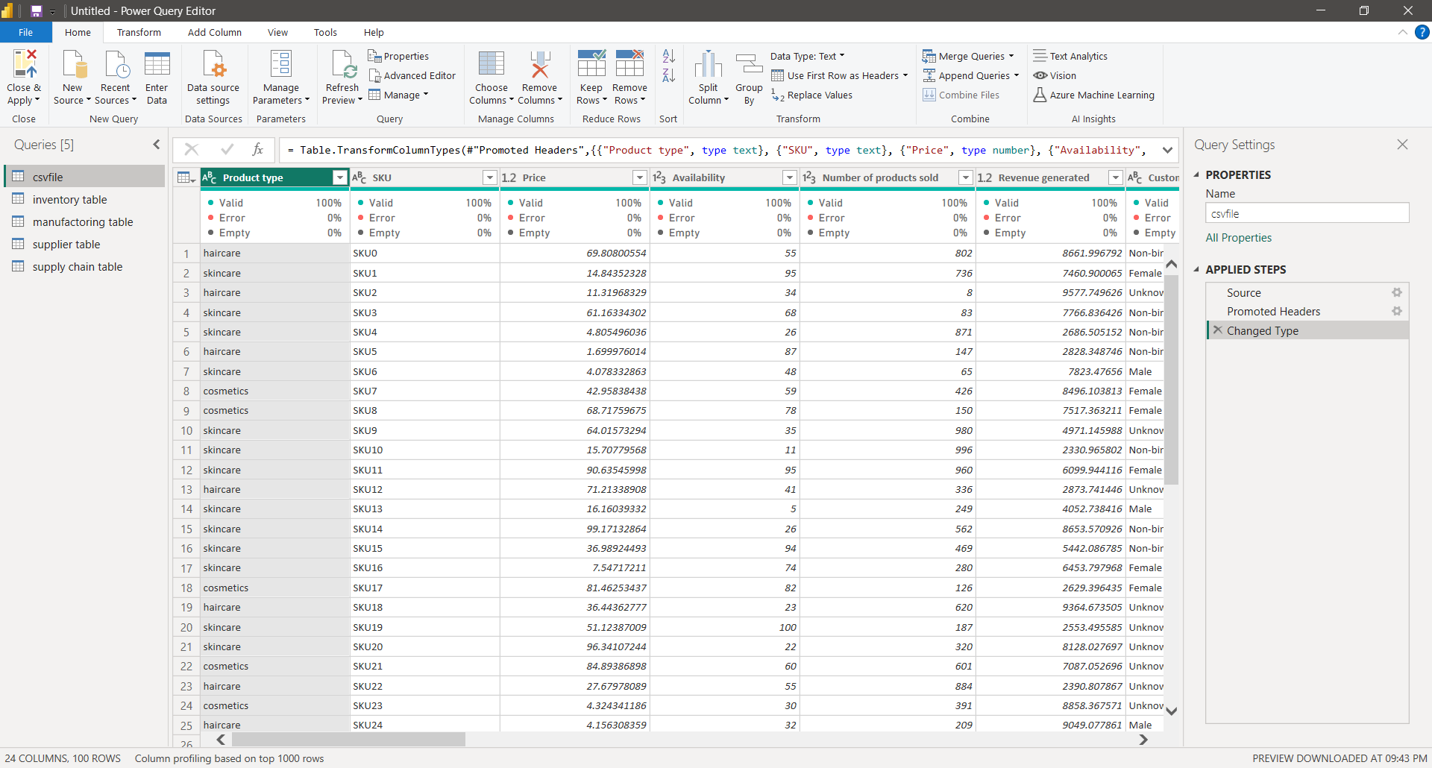

Step 1: duplicate the data table from the initial cvs file ,rename it as required table to be created. Then to form following table remove all the not required columns by right clicking on that specific column -->remove.

Inventory Table:

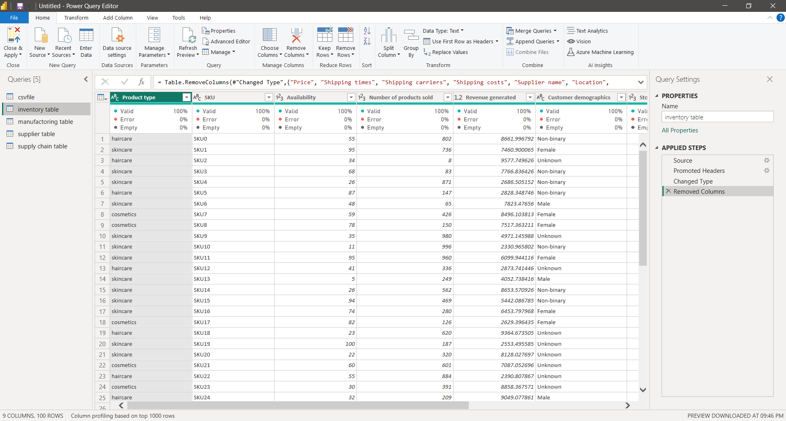

Step 2: duplicate the data table from the initial cvs file ,rename it as required table to be created. Then to form following table remove all the not required columns by right clicking on that specific column -->remove.

Manufacturing table:

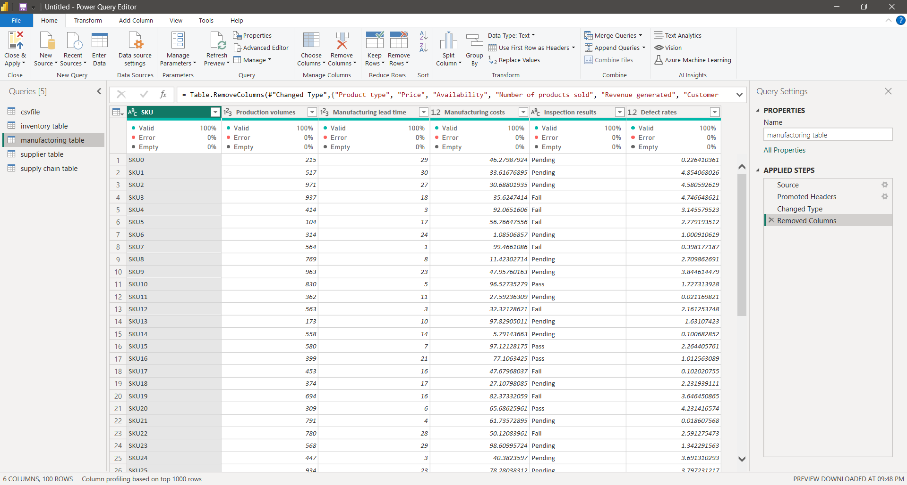

Step 3: duplicate the data table from the initial cvs file ,rename it as required table to be created. Then to form following table remove all the not required columns by right clicking on that specific column -->remove. Supplier Table:

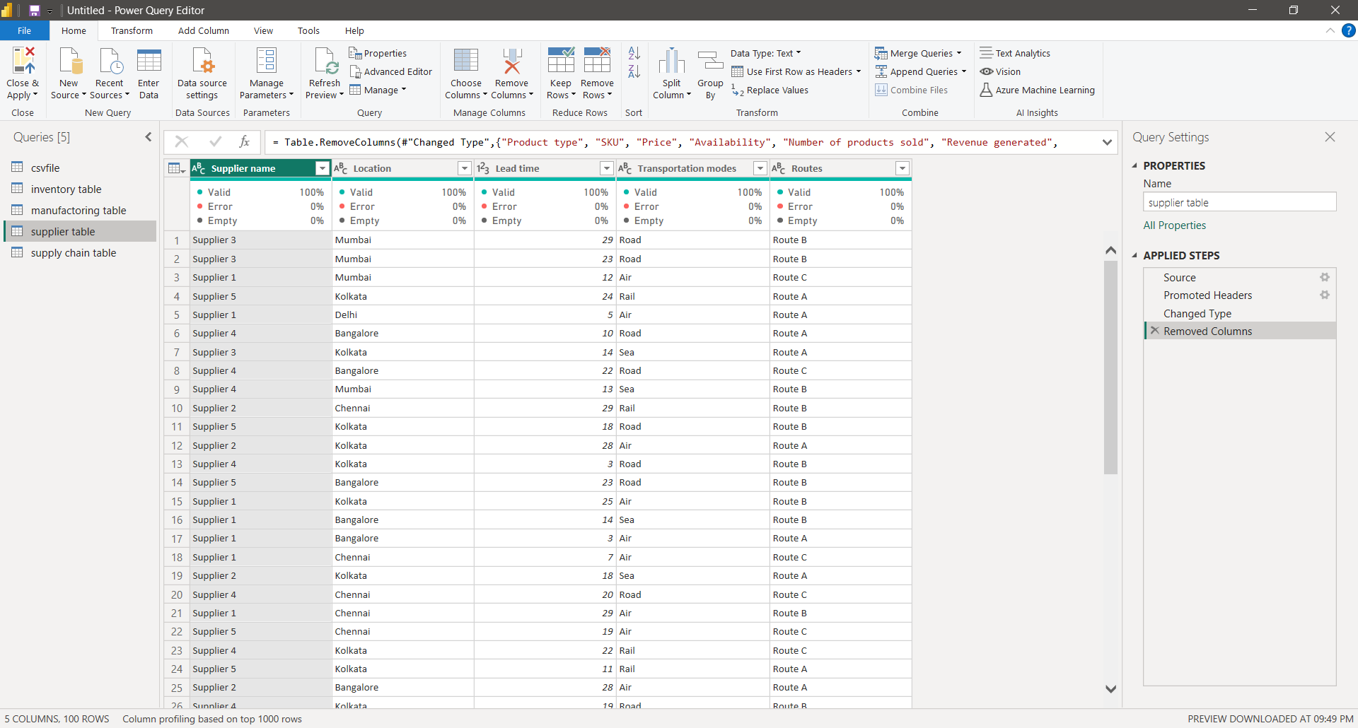

Step 4: duplicate the data table from the initial cvs file ,rename it as required table to be created. Then to form following table remove all the not required columns by right clicking on that specific column -->remove.

Supply chain table:

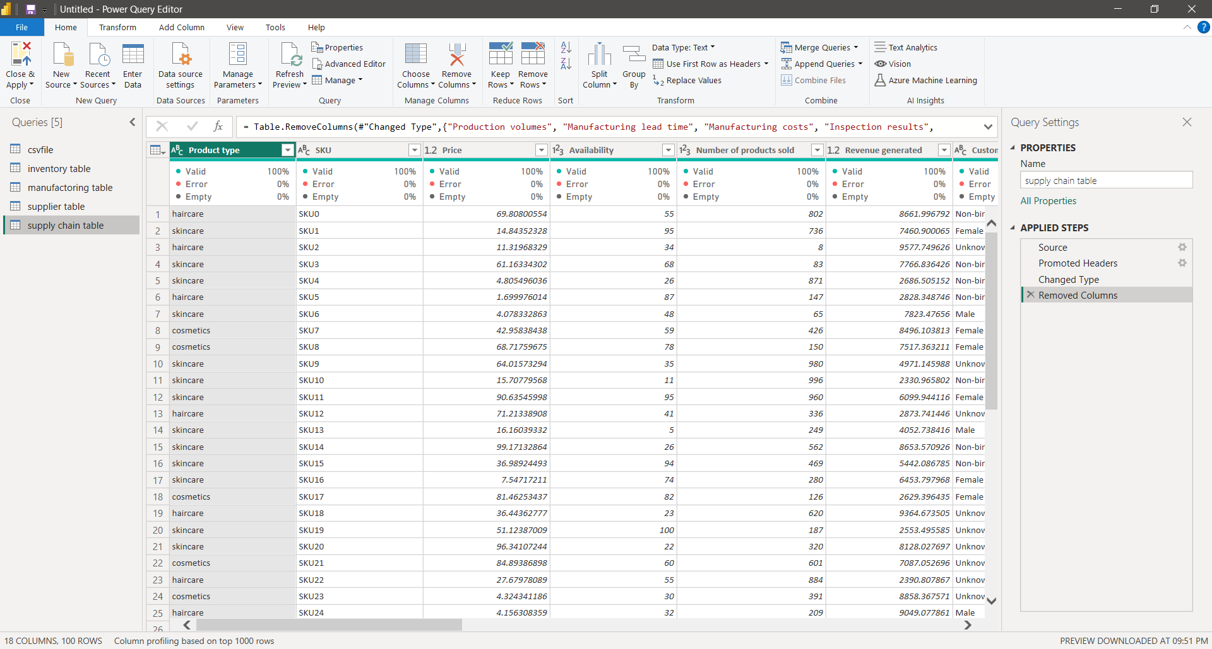Once all the tables are created, at the top left CLOSE AND APPLY option should be selected once it is chosen then all the created tables are saved and the interface is returned to the canvas.

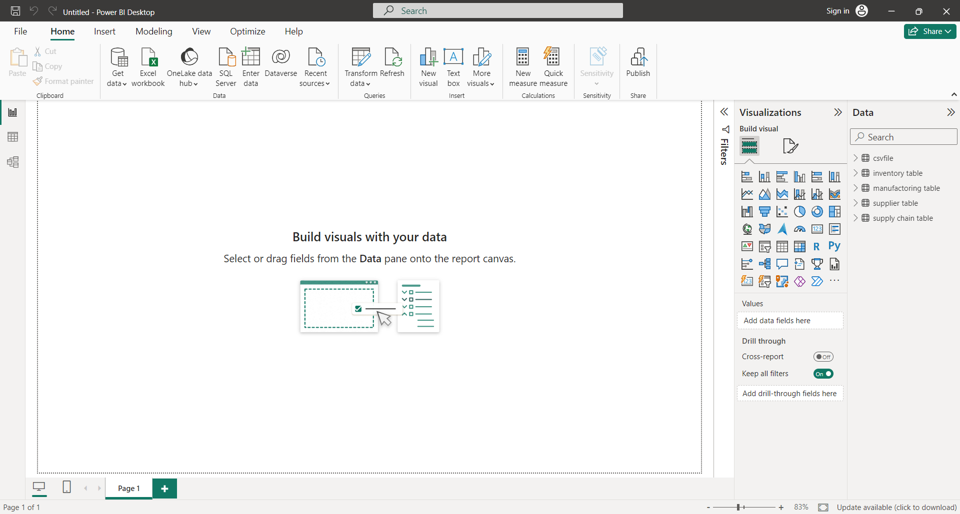The tables created have relations between them this can be viewed by selecting TABLE VIEW that is available at left column space.

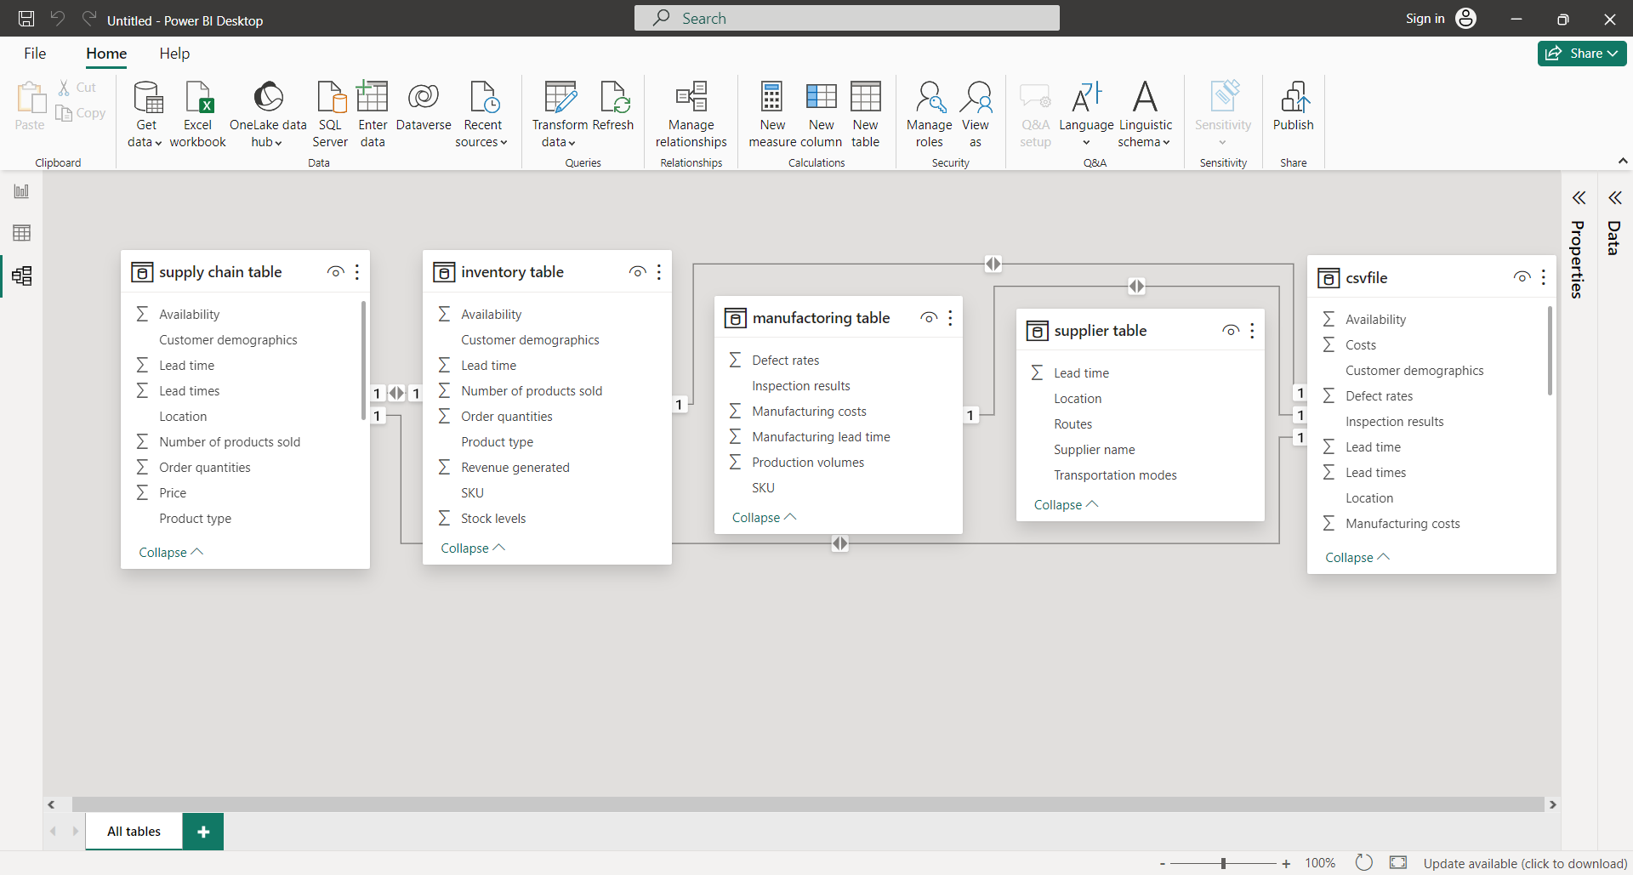Now all the tables have been created from the initial data set and ready to be visualized.